Outlier detection with Local Outlier Factor (LOF)
The Local Outlier Factor (LOF) algorithm is an unsupervised anomaly detection method which computes the local density deviation of a given data point with respect to its neighbors. It considers as outliers the samples that have a substantially lower density than their neighbors. This example shows how to use LOF for outlier detection which is the default use case of this estimator in scikit-learn. Note that when LOF is used for outlier detection it has no predict, decision_function and score_samples methods.
The number of neighbors considered (parameter n_neighbors) is typically set 1) greater than the minimum number of samples a cluster has to contain, so that other samples can be local outliers relative to this cluster, and 2) smaller than the maximum number of close by samples that can potentially be local outliers. In practice, such informations are generally not available, and taking n_neighbors=20 appears to work well in general.
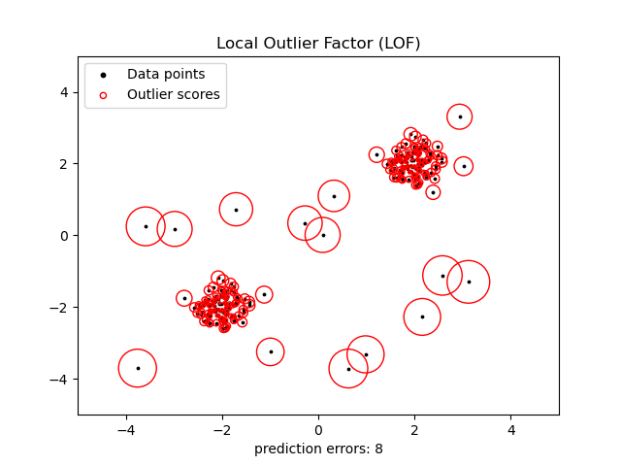

https://scikit-learn.org/stable/modules/outlier_detection.html#outlier-detection

2.7. Novelty and Outlier Detection
Many applications require being able to decide whether a new observation belongs to the same distribution as existing observations (it is an inlier), or should be considered as different (it is an outlier). Often, this ability is used to clean real data sets. Two important distinctions must be made:
outlier detection
The training data contains outliers which are defined as observations that are far from the others. Outlier detection estimators thus try to fit the regions where the training data is the most concentrated, ignoring the deviant observations.
novelty detection
The training data is not polluted by outliers and we are interested in detecting whether a new observation is an outlier. In this context an outlier is also called a novelty.
Outlier detection and novelty detection are both used for anomaly detection, where one is interested in detecting abnormal or unusual observations. Outlier detection is then also known as unsupervised anomaly detection and novelty detection as semi-supervised anomaly detection. In the context of outlier detection, the outliers/anomalies cannot form a dense cluster as available estimators assume that the outliers/anomalies are located in low density regions. On the contrary, in the context of novelty detection, novelties/anomalies can form a dense cluster as long as they are in a low density region of the training data, considered as normal in this context.
The scikit-learn project provides a set of machine learning tools that can be used both for novelty or outlier detection. This strategy is implemented with objects learning in an unsupervised way from the data:
estimator.fit(X_train)
new observations can then be sorted as inliers or outliers with a predict method:
estimator.predict(X_test)
Inliers are labeled 1, while outliers are labeled -1. The predict method makes use of a threshold on the raw scoring function computed by the estimator. This scoring function is accessible through the score_samples method, while the threshold can be controlled by the contamination parameter.
The decision_function method is also defined from the scoring function, in such a way that negative values are outliers and non-negative ones are inliers:
estimator.decision_function(X_test)
Note that neighbors.LocalOutlierFactor does not support predict, decision_function and score_samples methods by default but only a fit_predict method, as this estimator was originally meant to be applied for outlier detection. The scores of abnormality of the training samples are accessible through the negative_outlier_factor_ attribute.
If you really want to use neighbors.LocalOutlierFactor for novelty detection, i.e. predict labels or compute the score of abnormality of new unseen data, you can instantiate the estimator with the novelty parameter set to True before fitting the estimator. In this case, fit_predict is not available.
Warning

Novelty detection with Local Outlier Factor
When novelty is set to True be aware that you must only use predict, decision_function and score_samples on new unseen data and not on the training samples as this would lead to wrong results. The scores of abnormality of the training samples are always accessible through the negative_outlier_factor_ attribute.
The behavior of neighbors.LocalOutlierFactor is summarized in the following table.
Method | Outlier detection | Novelty detection
fit_predict | OK | Not available
predict | Not available | Use only on new data
decision_function | Not available | Use only on new data
score_samples | Use negative_outlier_factor_ | Use only on new data

2.7.1. Overview of outlier detection methods
A comparison of the outlier detection algorithms in scikit-learn. Local Outlier Factor (LOF) does not show a decision boundary in black as it has no predict method to be applied on new data when it is used for outlier detection.
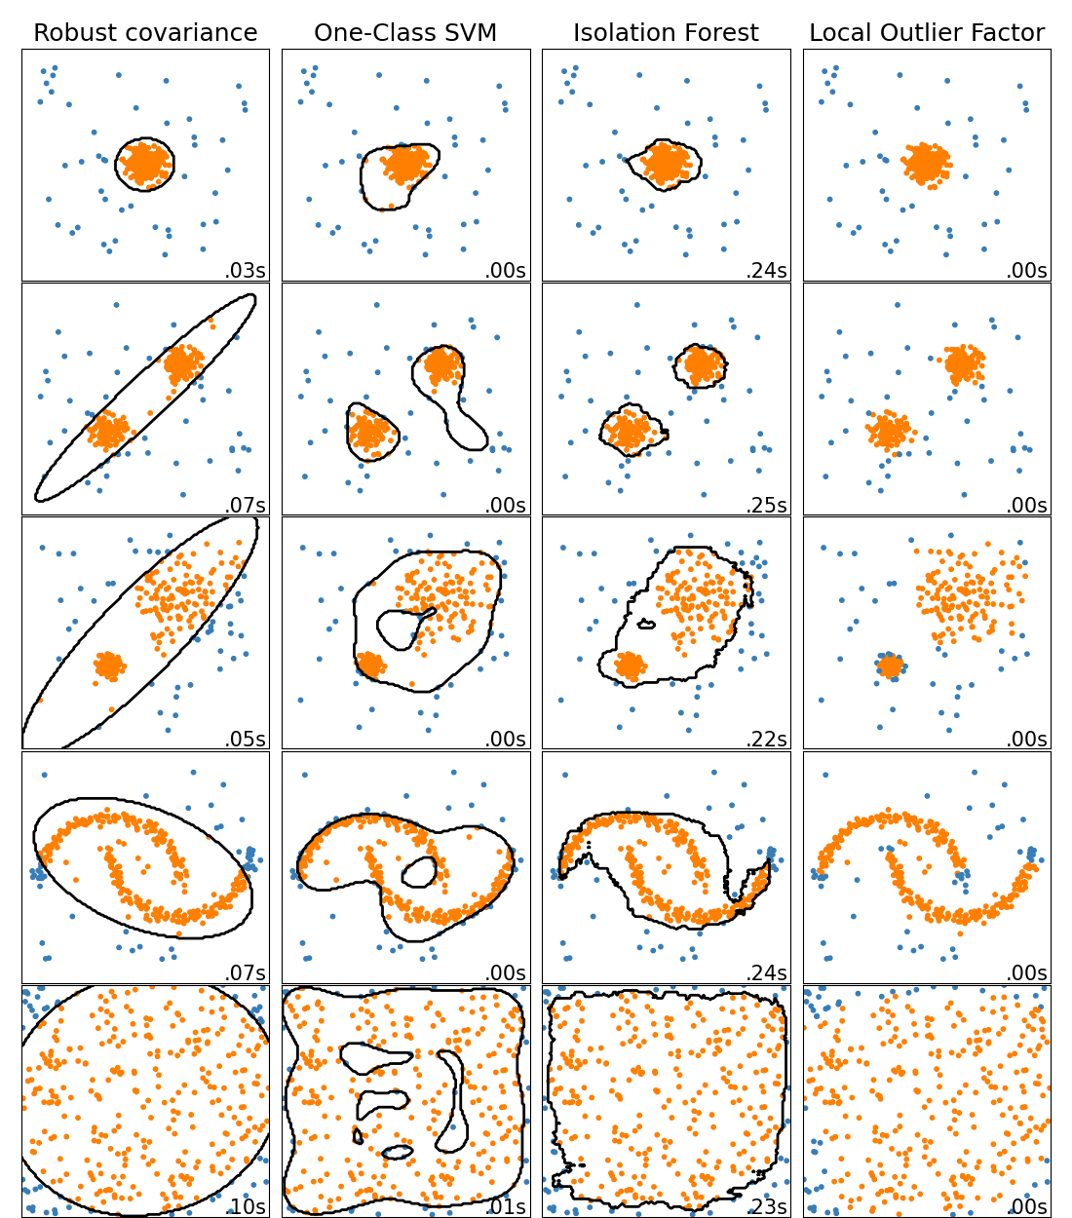
ensemble.IsolationForest and neighbors.LocalOutlierFactor perform reasonably well on the data sets considered here. The svm.OneClassSVM is known to be sensitive to outliers and thus does not perform very well for outlier detection. That being said, outlier detection in high-dimension, or without any assumptions on the distribution of the inlying data is very challenging. svm.OneClassSVM may still be used with outlier detection but requires fine-tuning of its hyperparameter nu to handle outliers and prevent overfitting. Finally, covariance.EllipticEnvelope assumes the data is Gaussian and learns an ellipse. For more details on the different estimators refer to the example Comparing anomaly detection algorithms for outlier detection on toy datasets and the sections hereunder.
Examples:
- See Comparing anomaly detection algorithms for outlier detection on toy datasets for a comparison of the svm.OneClassSVM, the ensemble.IsolationForest, the neighbors.LocalOutlierFactor and covariance.EllipticEnvelope.

2.7.2. Novelty Detection
Consider a data set of n observations from the same distribution described by p features. Consider now that we add one more observation to that data set. Is the new observation so different from the others that we can doubt it is regular? (i.e. does it come from the same distribution?) Or on the contrary, is it so similar to the other that we cannot distinguish it from the original observations? This is the question addressed by the novelty detection tools and methods.
In general, it is about to learn a rough, close frontier delimiting the contour of the initial observations distribution, plotted in embedding p-dimensional space. Then, if further observations lay within the frontier-delimited subspace, they are considered as coming from the same population than the initial observations. Otherwise, if they lay outside the frontier, we can say that they are abnormal with a given confidence in our assessment.
The One-Class SVM has been introduced by Schölkopf et al. for that purpose and implemented in the Support Vector Machines module in the svm.OneClassSVM object. It requires the choice of a kernel and a scalar parameter to define a frontier. The RBF kernel is usually chosen although there exists no exact formula or algorithm to set its bandwidth parameter. This is the default in the scikit-learn implementation. The nu parameter, also known as the margin of the One-Class SVM, corresponds to the probability of finding a new, but regular, observation outside the frontier.
References:
- Estimating the support of a high-dimensional distribution Schölkopf, Bernhard, et al. Neural computation 13.7 (2001): 1443-1471.
Examples:
- See One-class SVM with non-linear kernel (RBF) for visualizing the frontier learned around some data by a svm.OneClassSVM object.
- Species distribution modeling
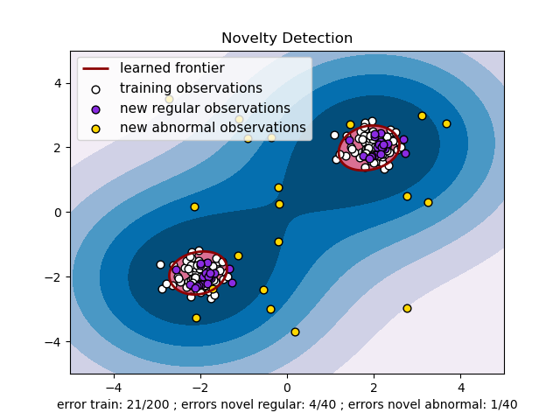

2.7.3. Outlier Detection
Outlier detection is similar to novelty detection in the sense that the goal is to separate a core of regular observations from some polluting ones, called outliers. Yet, in the case of outlier detection, we don’t have a clean data set representing the population of regular observations that can be used to train any tool.

2.7.3.1. Fitting an elliptic envelope
One common way of performing outlier detection is to assume that the regular data come from a known distribution (e.g. data are Gaussian distributed). From this assumption, we generally try to define the “shape” of the data, and can define outlying observations as observations which stand far enough from the fit shape.
The scikit-learn provides an object covariance.EllipticEnvelope that fits a robust covariance estimate to the data, and thus fits an ellipse to the central data points, ignoring points outside the central mode.
For instance, assuming that the inlier data are Gaussian distributed, it will estimate the inlier location and covariance in a robust way (i.e. without being influenced by outliers). The Mahalanobis distances obtained from this estimate is used to derive a measure of outlyingness. This strategy is illustrated below.
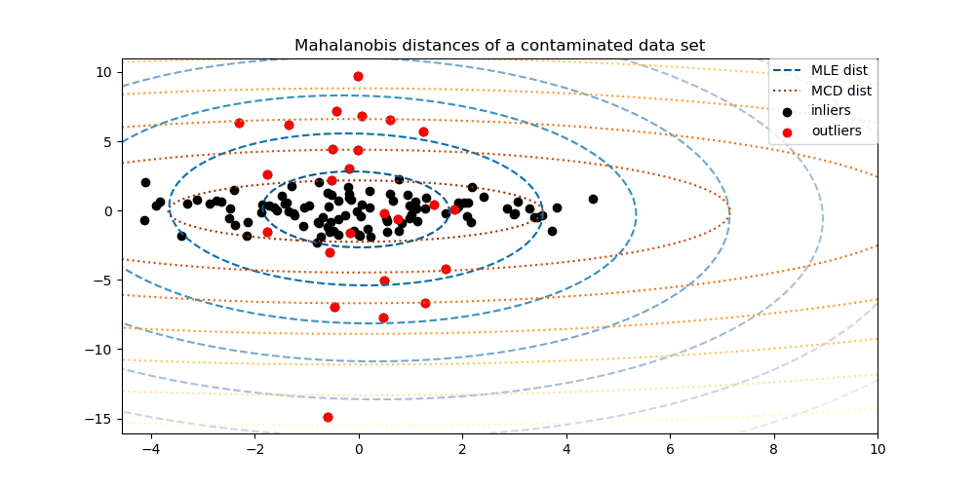
Examples:
- See Robust covariance estimation and Mahalanobis distances relevance for an illustration of the difference between using a standard (covariance.EmpiricalCovariance) or a robust estimate (covariance.MinCovDet) of location and covariance to assess the degree of outlyingness of an observation.
References:
- Rousseeuw, P.J., Van Driessen, K. “A fast algorithm for the minimum covariance determinant estimator” Technometrics 41(3), 212 (1999)

2.7.3.2. Isolation Forest
One efficient way of performing outlier detection in high-dimensional datasets is to use random forests. The ensemble.IsolationForest ‘isolates’ observations by randomly selecting a feature and then randomly selecting a split value between the maximum and minimum values of the selected feature.
Since recursive partitioning can be represented by a tree structure, the number of splittings required to isolate a sample is equivalent to the path length from the root node to the terminating node.
This path length, averaged over a forest of such random trees, is a measure of normality and our decision function.
Random partitioning produces noticeably shorter paths for anomalies. Hence, when a forest of random trees collectively produce shorter path lengths for particular samples, they are highly likely to be anomalies.
The implementation of ensemble.IsolationForest is based on an ensemble of tree.ExtraTreeRegressor. Following Isolation Forest original paper, the maximum depth of each tree is set to ⌈log2⁡(n)⌉ where n is the number of samples used to build the tree (see (Liu et al., 2008) for more details).
This algorithm is illustrated below.
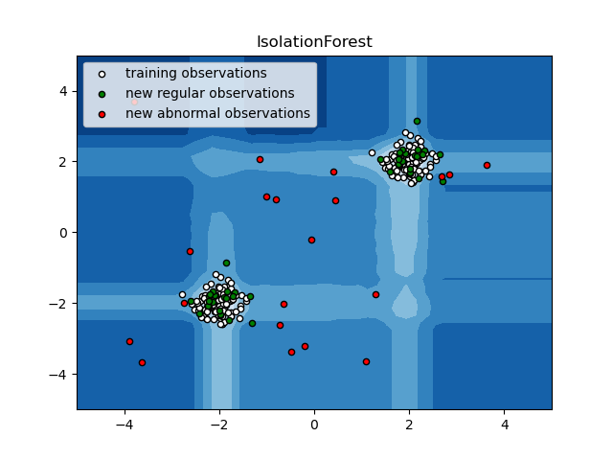
The ensemble.IsolationForest supports warm_start=True which allows you to add more trees to an already fitted model:
>>>
>>> from sklearn.ensemble import IsolationForest
>>> import numpy as np
>>> X = np.array([[-1, -1], [-2, -1], [-3, -2], [0, 0], [-20, 50], [3, 5]])
>>> clf = IsolationForest(n_estimators=10, warm_start=True)
>>> clf.fit(X) # fit 10 trees
>>> clf.set_params(n_estimators=20) # add 10 more trees
>>> clf.fit(X) # fit the added trees
Examples:
- See IsolationForest example for an illustration of the use of IsolationForest.
- See Comparing anomaly detection algorithms for outlier detection on toy datasets for a comparison of ensemble.IsolationForest with neighbors.LocalOutlierFactor, svm.OneClassSVM (tuned to perform like an outlier detection method) and a covariance-based outlier detection with covariance.EllipticEnvelope.
References:
- Liu, Fei Tony, Ting, Kai Ming and Zhou, Zhi-Hua. “Isolation forest.” Data Mining, 2008. ICDM’08. Eighth IEEE International Conference on.

2.7.3.3. Local Outlier Factor
Another efficient way to perform outlier detection on moderately high dimensional datasets is to use the Local Outlier Factor (LOF) algorithm.
The neighbors.LocalOutlierFactor (LOF) algorithm computes a score (called local outlier factor) reflecting the degree of abnormality of the observations. It measures the local density deviation of a given data point with respect to its neighbors. The idea is to detect the samples that have a substantially lower density than their neighbors.
In practice the local density is obtained from the k-nearest neighbors. The LOF score of an observation is equal to the ratio of the average local density of his k-nearest neighbors, and its own local density: a normal instance is expected to have a local density similar to that of its neighbors, while abnormal data are expected to have much smaller local density.
The number k of neighbors considered, (alias parameter n_neighbors) is typically chosen 1) greater than the minimum number of objects a cluster has to contain, so that other objects can be local outliers relative to this cluster, and 2) smaller than the maximum number of close by objects that can potentially be local outliers. In practice, such informations are generally not available, and taking n_neighbors=20 appears to work well in general. When the proportion of outliers is high (i.e. greater than 10 %, as in the example below), n_neighbors should be greater (n_neighbors=35 in the example below).
The strength of the LOF algorithm is that it takes both local and global properties of datasets into consideration: it can perform well even in datasets where abnormal samples have different underlying densities. The question is not, how isolated the sample is, but how isolated it is with respect to the surrounding neighborhood.
When applying LOF for outlier detection, there are no predict, decision_function and score_samples methods but only a fit_predict method. The scores of abnormality of the training samples are accessible through the negative_outlier_factor_ attribute. Note that predict, decision_function and score_samples can be used on new unseen data when LOF is applied for novelty detection, i.e. when the novelty parameter is set to True. See Novelty detection with Local Outlier Factor.
This strategy is illustrated below.
Examples:
- See Outlier detection with Local Outlier Factor (LOF) for an illustration of the use of neighbors.LocalOutlierFactor.
- See Comparing anomaly detection algorithms for outlier detection on toy datasets for a comparison with other anomaly detection methods.
References:
- Breunig, Kriegel, Ng, and Sander (2000) LOF: identifying density-based local outliers. Proc. ACM SIGMOD

2.7.4. Novelty detection with Local Outlier Factor
To use neighbors.LocalOutlierFactor for novelty detection, i.e. predict labels or compute the score of abnormality of new unseen data, you need to instantiate the estimator with the novelty parameter set to True before fitting the estimator:
lof = LocalOutlierFactor(novelty=True)
lof.fit(X_train)
Note that fit_predict is not available in this case.
Warning

Novelty detection with Local Outlier Factor`
When novelty is set to True be aware that you must only use predict, decision_function and score_samples on new unseen data and not on the training samples as this would lead to wrong results. The scores of abnormality of the training samples are always accessible through the negative_outlier_factor_ attribute.
Novelty detection with Local Outlier Factor is illustrated below.
